**Lab Exercise 10– Creating Deployment in Kubernetes**

Below is a lab exercise that demonstrates how to create and manage a Deployment in Kubernetes.

**Step 1: Create a Deployment Configuration File**

Create a file named deployment.yaml with the following configuration:

Link of file: (Coly following code from my GitHub repo)

<https://github.com/hkshitesh/ACO-LAB-2021-25/blob/main/scripts/deployment.yaml>

apiVersion: apps/v1

kind: Deployment

metadata:

name: apache-deployment

labels:

app: web

spec:

replicas: 10

selector:

matchLabels:

app: web

template:

metadata:

labels:

app: web

spec:

containers:

- name: httpd

image: httpd

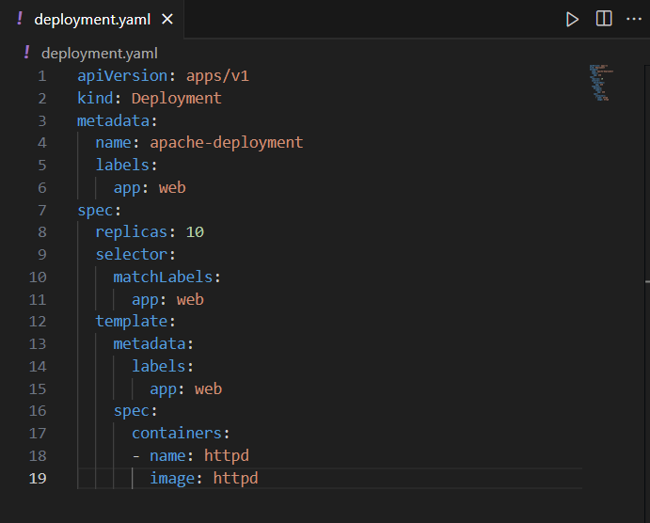

**Step 2: Apply the Deployment Configuration**

Apply the configuration to create the Deployment:

kubectl apply -f deployment.yaml



**Step 3: View the Deployment and Pods**

View the created Deployment and the associated Pods:

kubectl get deployments

kubectl get pods

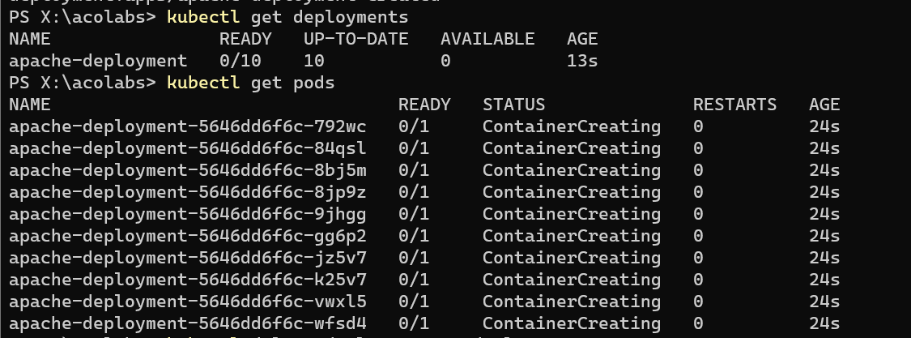

**Step 4: Delete the Deployment**

Delete the Deployment:

kubectl delete deployment my-deployment

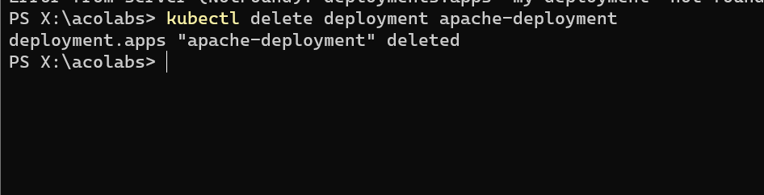

**Conclusion**

This exercise demonstrated how to create, manage, and update a Deployment in Kubernetes. You learned how to scale the Deployment, update the image, and perform a rolling update to the Deployment. Experiment further with different configurations and update strategies to deepen your understanding of managing Deployments in Kubernetes.